The steps are to be performed to manually test creation of users, reading and deleting users through an admin log on, creation, reading, editing and deletion of records as a logged in user.

|  |  |  |  |
| --- | --- | --- | --- |
| Step | Test | Expected Outcome | Actual Outcome |
| 01 | Click ‘Add +’ link in navbar | Sign in page is rendered | N/A |
| 02 | Click ‘sign up’ link in the navbar | Sign up page is rendered | N/A |
| 03 | Create the following user;  Email: user1@user1  Username: user1  Password: user1  Click ‘SIGN UP!’ | Form is submitted and login page is rendered | N/A |
| 04 | Log in with user1 credentials  Click ‘LOGIN’ | Form is submitted and login page is rendered with message ‘Hello user1 you are logged in!’  ‘Login’ and ‘Sign up’ links in navbar are not present. ‘Logout’ link now appears. | N/A |
| 05 | Click ‘Add +’ link in navbar | Add page is rendered | N/A |
| 06 | Add the following record;  Word or phrase: Test1  Definition: Test1  Example: Test1  Click ‘Submit’ | Form is submitted and added page is rendered with message ‘Your word or phrase has been added successfully’ | N/A |
| 07 | Click Browse – All link in navbar | Browse page is rendered showing all records in database. Test1 record is present. ‘Edit’ and ‘Delete’ buttons are present.  ‘User1’ and date added is cited at the bottom of the record. | N/A |
| 08 | Click Edit button | Edit page is rendered showing all pre-filled form for Test1. |  |
| 09 | Change Definition from ‘Test1’ to ‘Testing1’.  Click ‘Submit’ | Form is submitted and edited page is rendered with message ‘Your word or phrase has been edited successfully’ | N/A |
| 10 | Click Browse – All link in navbar | Browse page is rendered showing all records in database. Test1 record is present. Definition has been updated with ‘Testing1’. | N/A |
| 11 | In the browser address bar change the URL from ‘https://mototorque-c015422a9ebb.herokuapp.com/browse?type=All’ to ‘https://mototorque-c015422a9ebb.herokuapp.com/admin’ | Home page is rendered. | N/A |
| 12 | Click Logout link in navbar | User is logged out. Signout page is rendered with the message ‘You have logged out!’  ‘Login’ and ‘Sign up’ links in navbar are now present. ‘Logout’ is not present. | N/A |
| 13 | Click ‘sign up’ link in the navbar | Sign up page is rendered | N/A |
| 14 | Create the following user;  Email: user2@user2  Username: user2  Password: user2  Click ‘SIGN UP!’ | Form is submitted and login page is rendered | N/A |
| 15 | Log in with user2 credentials  Click ‘LOGIN’ | Form is submitted and login page is rendered with message ‘Hello user2 you are logged in!’  ‘Login’ and ‘Sign up’ links in navbar are not present. ‘Logout’ link now appears. | N/A |
| 16 | Click ‘Add +’ link in navbar | Add page is rendered | N/A |
| 17 | Add the following record;  Word or phrase: Test2  Definition: Test2  Example: Test2  Click ‘Submit’ | Form is submitted and added page is rendered with message ‘Your word or phrase has been added successfully’ | N/A |
| 18 | Click Browse – All link in navbar | Browse page is rendered showing all records in database. Test1 & Test2 records are present. ‘Edit’ and ‘Delete’ buttons are present on Test2 only.  ‘User2’ and date added is cited at the bottom of the record. | N/A |
| 19 | Click Logout link in navbar | User is logged out. Signout page is rendered with the message ‘You have logged out!’  ‘Login’ and ‘Sign up’ links in navbar are now present. ‘Logout’ is not present. | N/A |
| 20 | Click ‘sign up’ link in the navbar | Sign up page is rendered | N/A |
| 21 | Create the following user;  Email: admin@admin  Username: admin  Password: admin  Click ‘SIGN UP!’ | Form is submitted and login page is rendered | N/A |
| 22 | Log in with admin credentials  Click ‘LOGIN’ | Form is submitted and admin page is rendered.  All signed up users are listed and delete button present.  ‘Login’ and ‘Sign up’ links in navbar are not present. ‘Logout’ and ‘Admin’ link now appears. | N/A |
| 23 | Click ‘Add +’ link in navbar | Add page is rendered | N/A |
| 24 | Add the following record;  Word or phrase: test3  Definition: test3  Example: test3  Click ‘Submit’ | Form is submitted and added page is rendered with message ‘Your word or phrase has been added successfully’ | N/A |
| 25 | Click Browse – All link in navbar | Browse page is rendered showing all records in database. Test1, Test2 & test3 records are present. ‘Edit’ and ‘Delete’ buttons are present on all records.  ‘admin’ and date added is cited at the bottom of the record. | N/A |
| 26 | In the browser address bar change the URL from ‘https://mototorque-c015422a9ebb.herokuapp.com/browse?type=All’ to ‘https://mototorque-c015422a9ebb.herokuapp.com/admin’ | Admin page is rendered. | N/A |
| 27 | Click Browse – T link in navbar | Browse page is rendered showing all records in database. Test1, Test2 & test3 records are present. ‘Edit’ and ‘Delete’ buttons are present on all records.  ‘admin’ and date added is cited at the bottom of the record. | **PASS**  See figure 1 |
| 28 | Click ‘Delete’ on task3 record | Modal appears with message ‘Warning! Are you sure you want to delete this?’ | **PASS**  See figure 2 |
| 29 | Click ‘Yes’ on modal | Deleted page is rendered with message ‘Your word or phrase has been deleted successfully’ | **PASS**  See figure 3 |
| 30 | Click Browse – All link in navbar | Browse page is rendered showing all records in database. Test1 & Test2 records are present. ‘Edit’ and ‘Delete’ buttons are present on all records. | **PASS**  See figure 4 |
| 31 | Click Admin link in navbar | Admin page is rendered.  All signed up users are listed and delete button present. | N/A |
| 32 | Click Delete button on user2 | user2 is removed from table | N/A |
| 33 | Click Logout link in navbar | User is logged out. Signout page is rendered with the message ‘You have logged out!’  ‘Login’ and ‘Sign up’ links in navbar are now present. ‘Logout’ and ‘Admin’ is not present. | N/A |
| 34 | Click Browse – All link in navbar | Browse page is rendered showing all records in database. Test1 & Test2 records are present. ‘Edit’ and ‘Delete’ buttons are not present on any records.  Deleted User and date added is cited on Test2 record. | N/A |
| 35 | Click Login link in navbar | Login page is rendered | N/A |
| 36 | Log in with user2 credentials  Click ‘LOGIN’ | Form is submitted and sorry page is rendered with message ‘Sorry, Your username or password was incorrect’ | N/A |
| 37 | Click ‘sign up’ link in the navbar | Sign up page is rendered | N/A |
| 38 | Create the following user;  Email: user1@user1  Username: user3  Password: user3  Click ‘SIGN UP!’ | Form is submitted and sorry2 page is rendered with message ‘Sorry, an account has already been made with this email address. If you have forgotten your username or password please contact an Administrator’ | N/A |
| 39 | Click ‘sign up’ link in the navbar | Sign up page is rendered | N/A |
| 40 | Create the following user;  Email: user3@user3  Username: user1  Password: user3  Click ‘SIGN UP!’ | Form is submitted and sorry3 page is rendered with message ‘Sorry, an account has already been made with this username. If you have forgotten your username or password please contact an Administrator’ | N/A |
| 41 | Click ‘sign up’ link in the navbar | Sign up page is rendered | N/A |
| 42 | Create the following user;  Email: ADMIN@ADMIN  Username: ADMIN  Password: ADMIN  Click ‘SIGN UP!’ | Form is submitted and login page is rendered | N/A |
| 43 | Log in with ADMIN credentials  Click ‘LOGIN’ | Form is submitted and login page is rendered with message ‘Hello ADMIN you are logged in!’  ‘Login’, ‘Sign up’ & ’Admin’ links in navbar are not present. ‘Logout’ link now appears. | N/A |
| 44 | Click Logout link in navbar | User is logged out. Signout page is rendered with the message ‘You have logged out!’  ‘Login’ and ‘Sign up’ links in navbar are now present. ‘Logout’ and ‘Admin’ is not present. | N/A |
| 45 | Click ‘sign up’ link in the navbar | Sign up page is rendered | N/A |
| 46 | Create the following user;  Email: Admin@Admin  Username: Admin  Password: Admin  Click ‘SIGN UP!’ | Form is submitted and login page is rendered | N/A |
| 47 | Log in with Admin credentials  Click ‘LOGIN’ | Form is submitted and login page is rendered with message ‘Hello ADMIN you are logged in!’  ‘Login’, ‘Sign up’ & ’Admin’ links in navbar are not present. ‘Logout’ link now appears. | N/A |

Figures

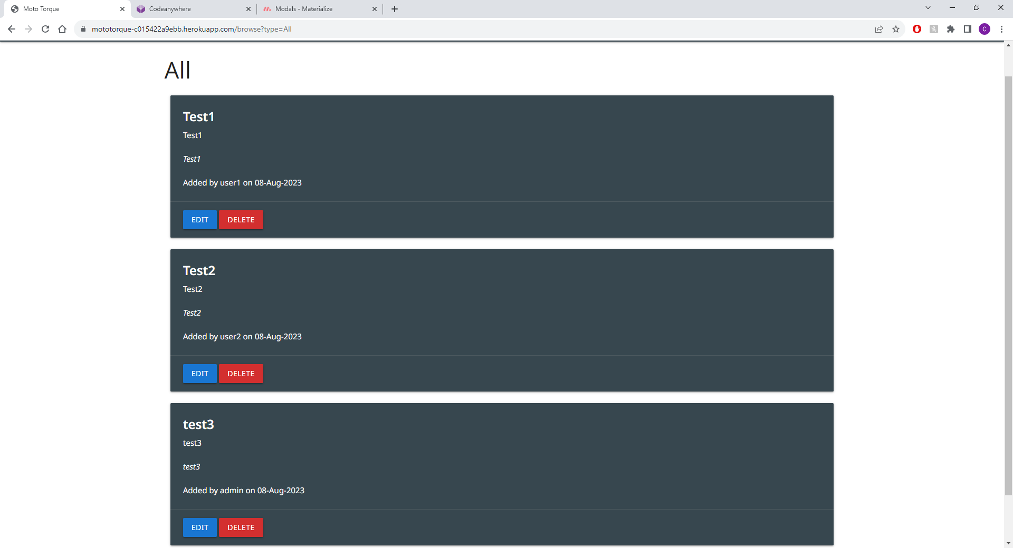

Figure 1

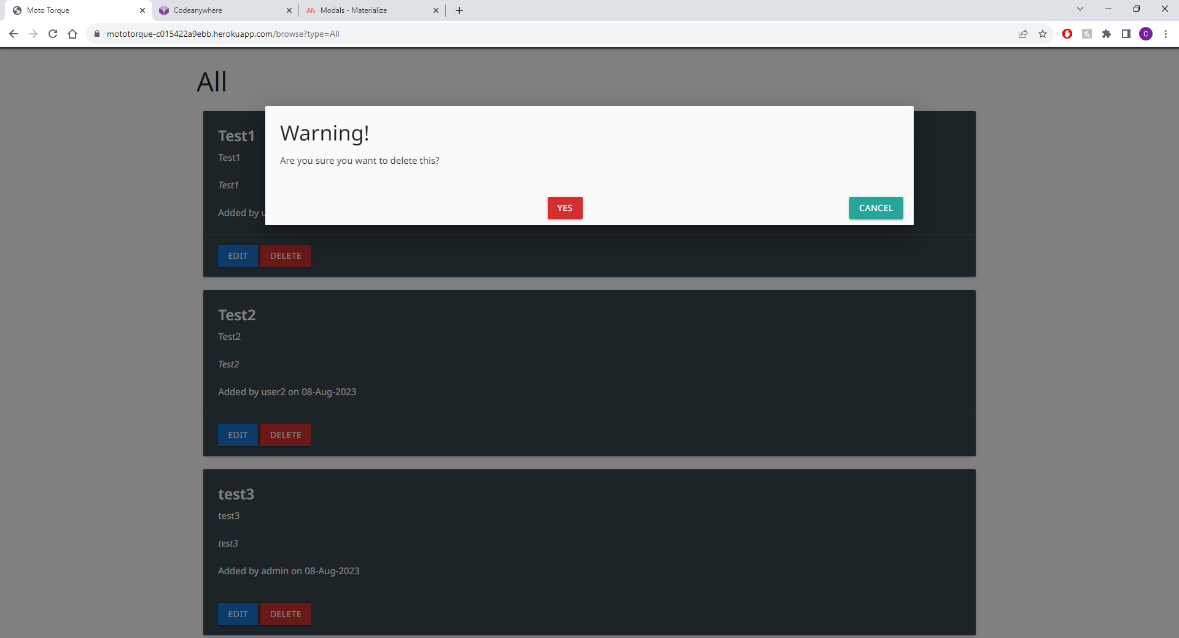

Figure 2

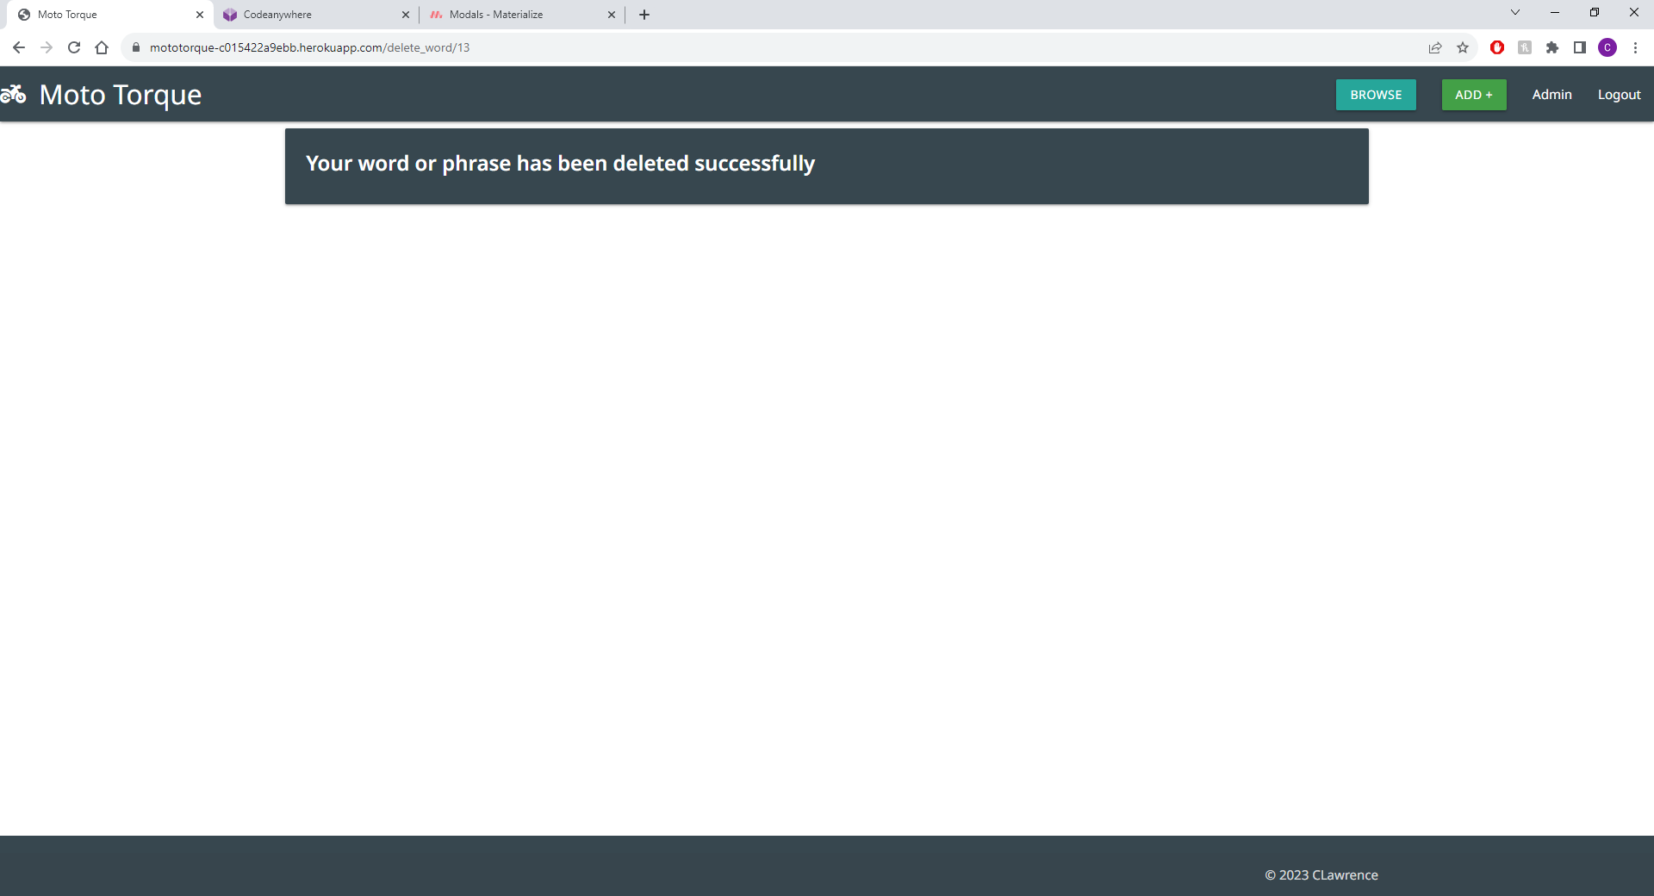

Figure 3

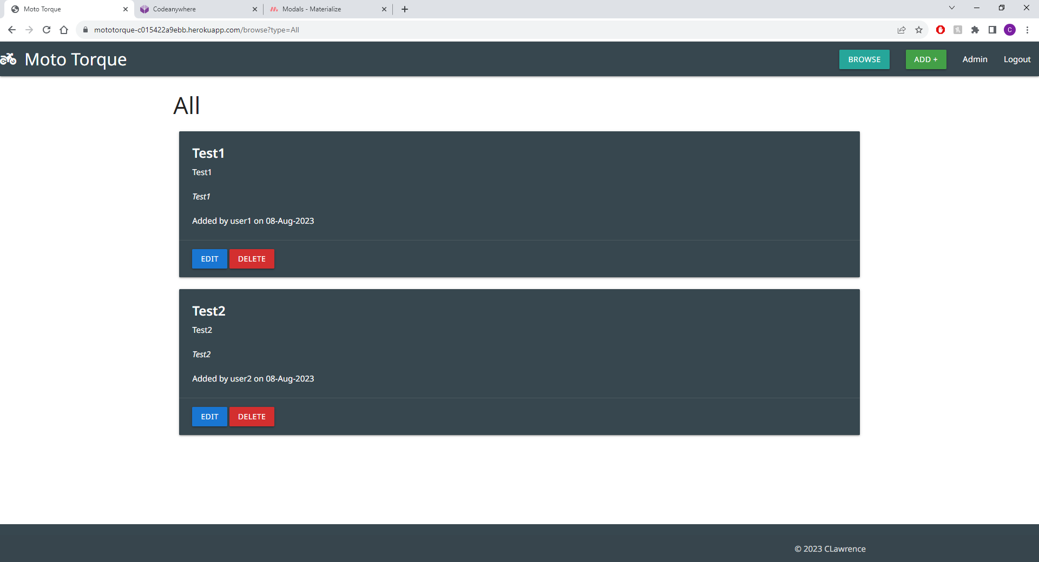

Figure 4